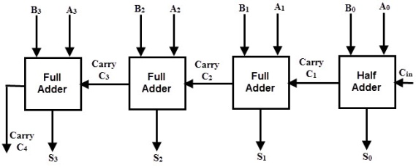**Circuit Diagram & Truth Table:**

|  |  |  |  |  |
| --- | --- | --- | --- | --- |
| **Cin** | **a** | **b** | **sum** | **Cout** |
| 0 | 0001 | 0010 | 0011 | 1 |
| 1 | 1010 | 1011 | 0110 | 1 |
| 1 | 1001 | 0110 | 0000 | 1 |
|  |

**Code:**

* **Design Module**

//design module 1 bit

module obfa(sum,cout,a,b,cin);

input a,b,cin;

output sum,cout;

wire x,y,z;

xor(x,a,b);

xor(sum,x,cin);

and a1(y,x,cin);

and a2(z,a,b);

or o1(cout,y,z);

endmodule

//design module 4 bit

module fbfa(sum,cout,a,b,cin);

input[3:0] a,b;

input cin;

output[3:0] sum;

output cout;

wire c1,c2,c3;

obfa fa1(sum[0],c1,a[0],b[0],cin);

obfa fa2(sum[1],c2,a[1],b[1],c1);

obfa fa3(sum[2],c3,a[2],b[2],c2);

obfa fa4(sum[3],cout,a[3],b[3],c3);

endmodule

* **TestBench**

module baig;

reg[3:0] a,b;

reg cin;

wire[3:0] sum;

wire cout;

fbfa g1(sum,cout,a,b,cin);

initial

begin

a=4'h1;b=4'h2;cin=1'b0;

#20

a=4'hA;b=4'hB;cin=1'b1;

#20

a=4'h9;b=4'h6;cin=1'b1;

#20

$finish;

end

endmodule

**Output:**

